# Introduction to Linux

# Exercise 1 Abhishek Maurya

1. **Create a directory "exercise" inside your home directory and create nested(dir1/dir2/dir3) directory structure inside "exercise" with single command.**
   * mkdir -p exercise/dir1/dir2/dir3

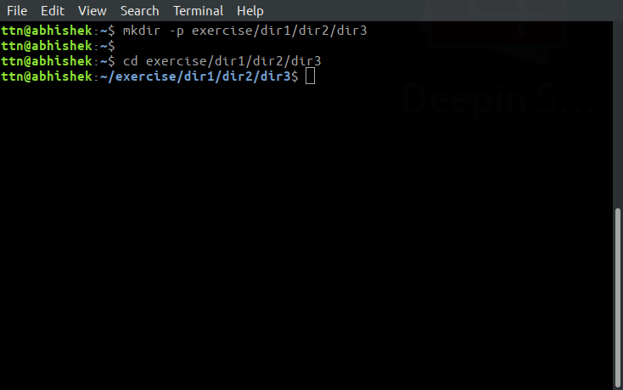

1. **Create two empty files inside dir2 directory: emptyFile1,emptyFile2 in single command.**
   * touch emptyFile1 emptyFile2

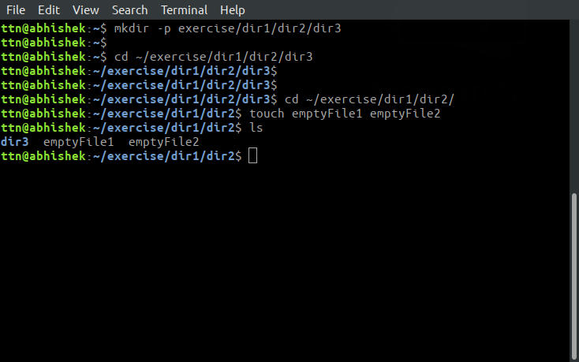

1. **Create one file file1.txt containing text "hello world" and save it.**
   * echo "hello world" > file1.txt

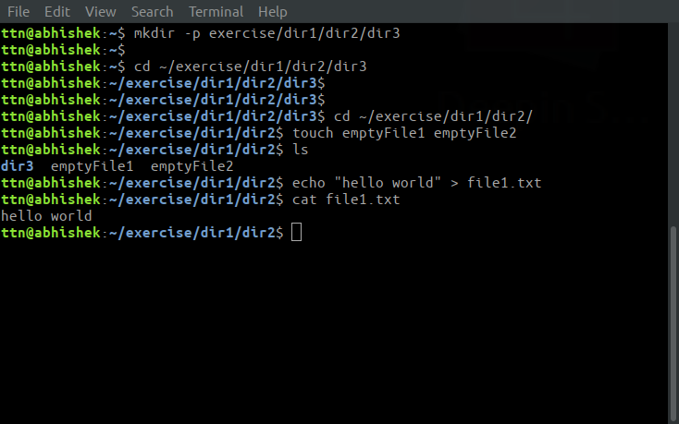

1. **Find a "passwd" file using find command inside /etc. copy this files as passwd_copy and then rename this file as passwd_backup.**
   * find /etc -name "passwd"
   * cp /etc/passwd ~/exercise/passwd_backup

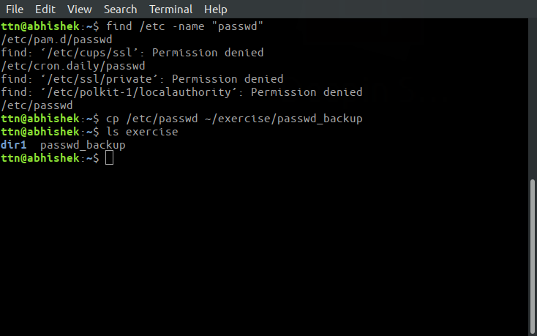

1. **Try reading passwd_backup file in multiple tools: less,more,cat,strings etc and find the difference in their usage.**
   * head passwd_backup
   * tail passwd_backup
   * Less passwd_backup

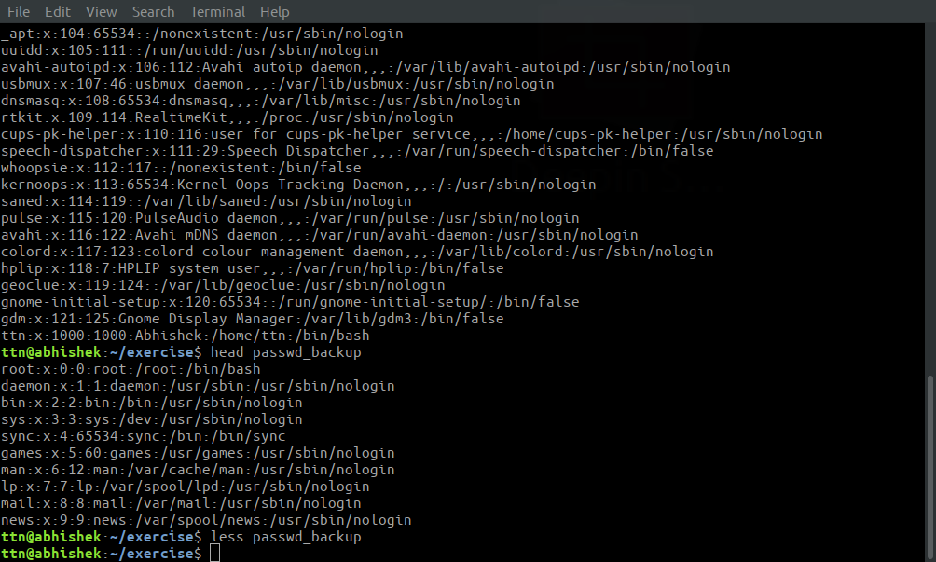

1. **Find out the number of line in password_backup containing "/bin/false".**
   * grep -rnw passwd_backup -e "/bin/false" | wc -l

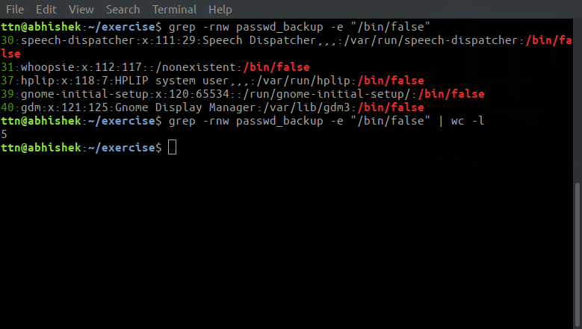

1. **Get the first 5 lines of a file “password_backup” and Redirect the output of the above commands into file "output".**
   * head -n 5 passwd_backup > output

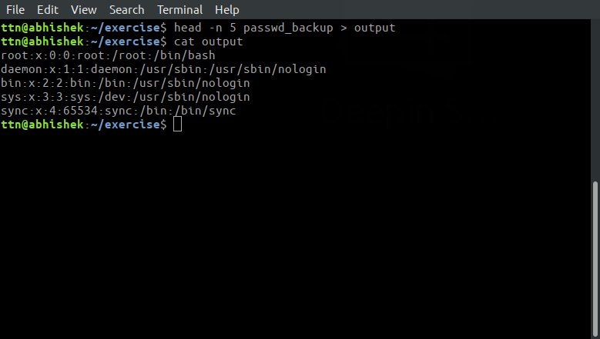

1. **Create a "test" user,create its password and find out its uid and gid.**
   * adduser test
   * id -u test
   * id -g test

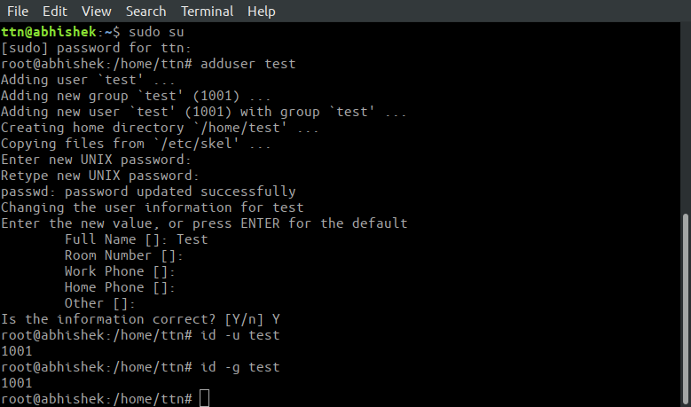

1. **Change the timestamp of emptyFile1,emptyFile2 which are exist in dir2.**
   * touch emptyFile1 emptyFile2

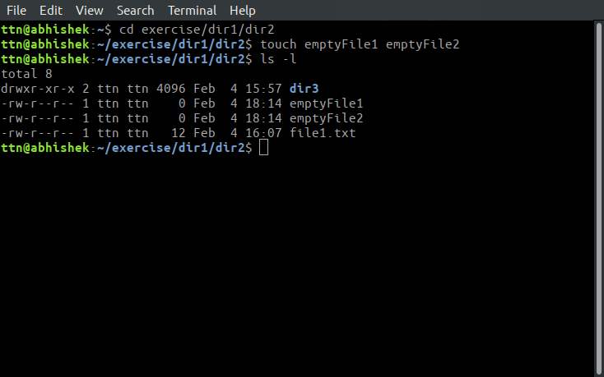

1. **Login as test user and edit the "output" file created above. Since the permission won’t allow you to save the changes. Configure such that test user can edit it.**
   * **Add group owner of the "output" file as the secondary group of testuser and check/change the "output" file permission if it is editable by group. Once done revert the changes**
   * **Make the file editable to the world so that test user can access it. Revert the changes after verification.**
   * **Change the ownership to edit the file.**
     + chown :test output
     + chmod 664 output
     + su - test
     + echo hello >> output

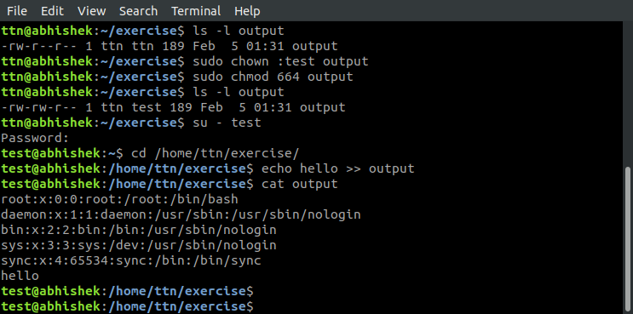

* + - chmod 666 output
    - chmod 644 output

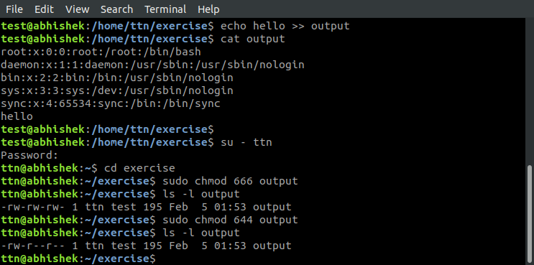

* + - chown test: output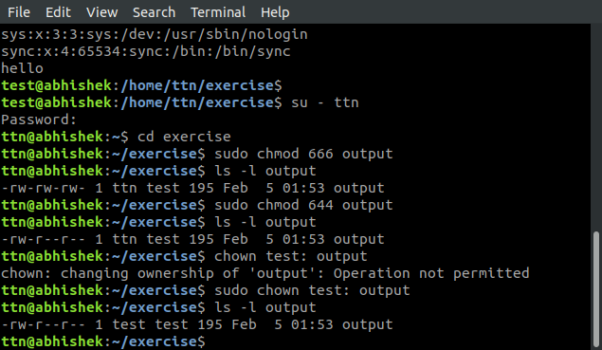

1. **Create alias with your name so that it creates a file as "/tmp/aliastesting".**
   * alias abhishek='mkdir -p /tmp/aliastesting'

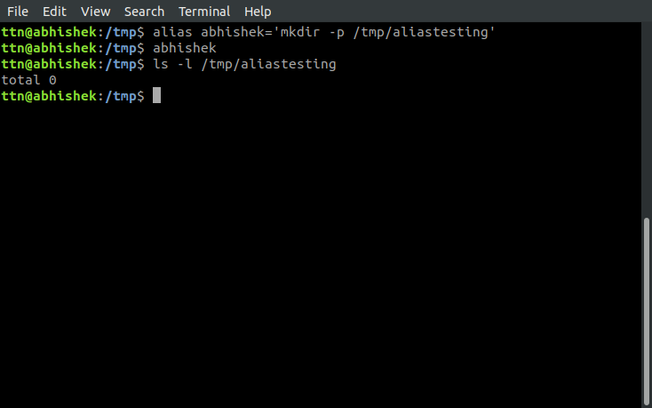

1. **Edit ~/.bashrc file such that when you change to "test" user it should clear the screen and print "Welcome".**
   * sudo gedit /home/test/.bashrc

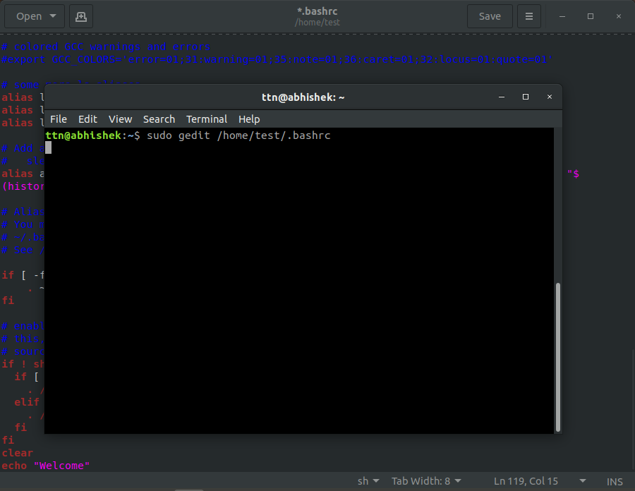

* + su - test

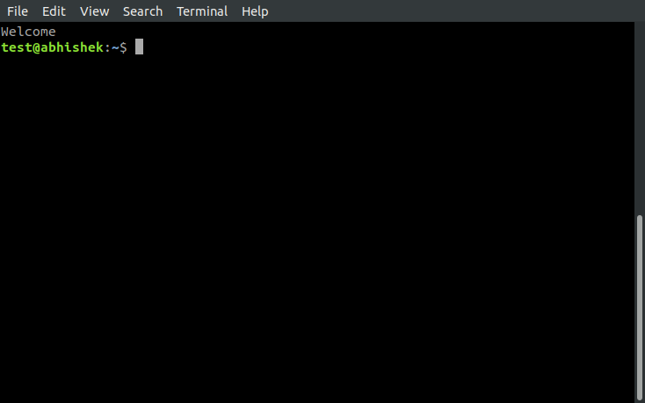

1. **Install “zip” package.**
   * sudo apt-get update

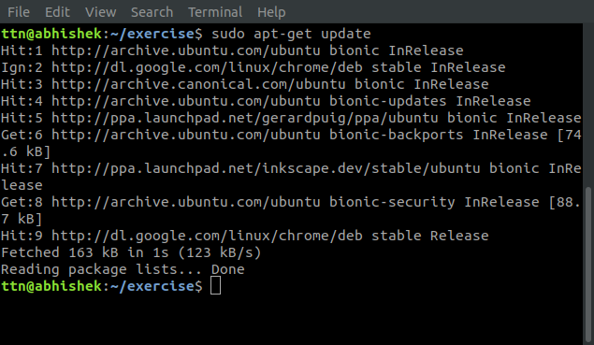

1. **Compress "output" and "password_backup" files into a tar ball. List the files present inside the tar created.**
   * tar -cvf archive.tar.gz passwd_backup output

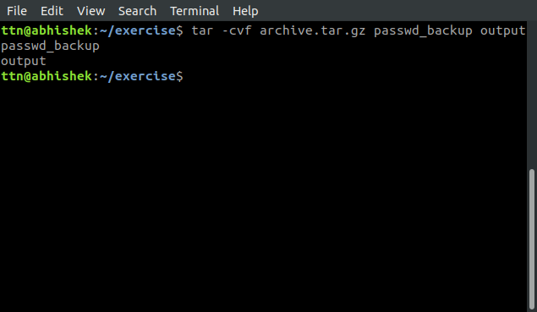

1. **scp this file to test user**
   * scp archive.tar.gz ttn@localhost.xyz:/home/remote/ttn

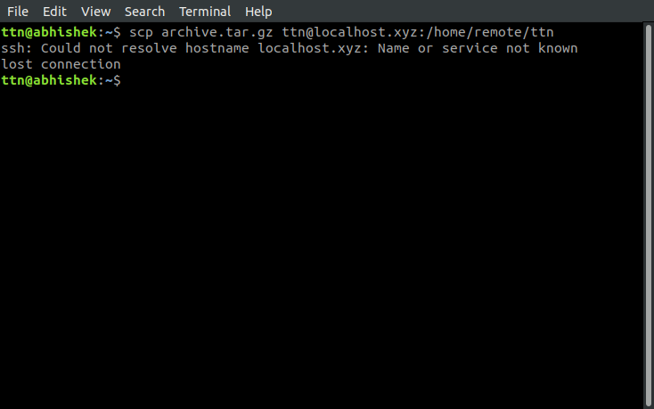

1. **Unzip this tar bar by logging into the remote server**
   * ssh user@host tar czf - /home/remote/ttn/
2. **Download any image from web and move to desktop**
   * wget http://www.tothenew.com/themes/ttnd/images/logo.png | mv ~/logo.png ~/Desktop

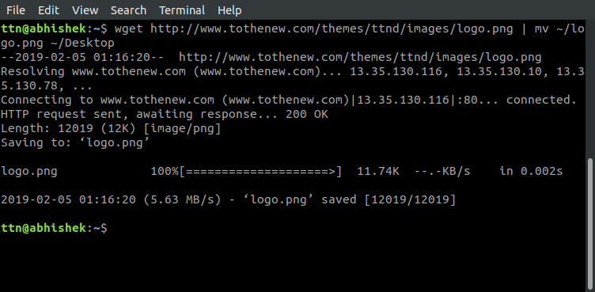

1. **How to get help of commands usages.**
   * by using whatis <command> , info <command>, man <command>, etc

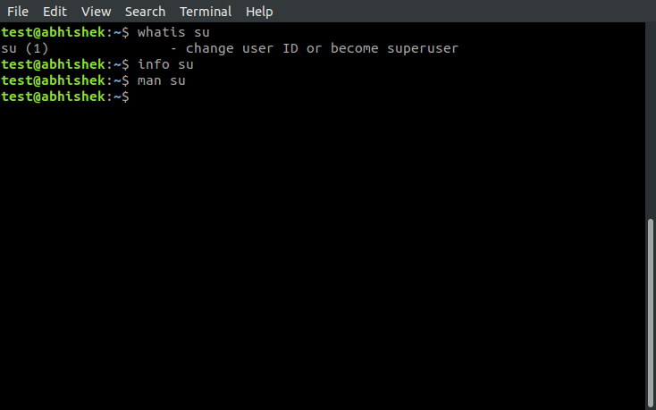

1. **Create a symlink of /etc/services into /tmp/ports-info**
   * ln -s /etc/services /tmp/ports-info

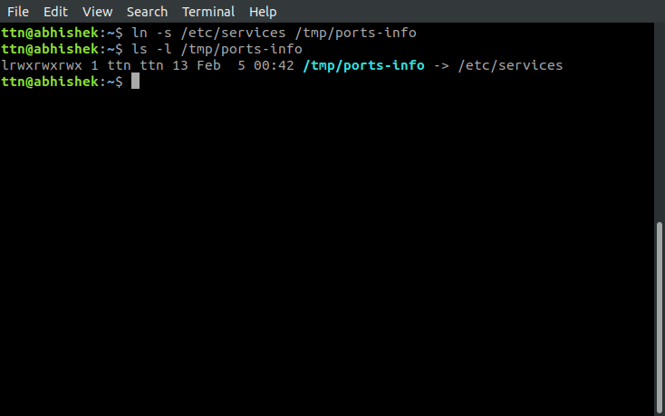

1. **You are appointed as a Software/DevOps Engineer in ABC media services. On your first day you need to troubleshoot a problem. There is a command “xyz” somewhere installed in that linux system. But as a new joinee you do not have any idea about where is that Installed. How can you check that?**
   * By using where is command

Ex-

